GARMENTS MANAGEMENT SYSTEM
ABSTRACT
A garments management system is used to track the all the details of the garments. The main purpose of this to handle and follow every order by the merchandiser. The merchandiser will folly every order once the order has been completed, he can follow up the next process and completed all the process he can report to his manager. There are five modules are using this application, 1. Worker Registration 2. Order registration 3.Order detail update 4. Order tracking 5. Order billing report
The same way of order the merchandiser follow up, once the status has been completed, he can navigate to the next order. This might be help to the garment for tracking every works and orders. The main purpose of this application is that managing the garments order by using this application and fast way to track all the details. Here for this application was using JAVA as Front End and SQL as back end.

SYSTEM SPECIFICATION
HARDWARE SPECFICATION:
- Processor : P 4 700 GHz.
- RAM : 4 GB RAM
- Hard Disk Drive : 180 GB

SOFTWARE SPECIFICATION:

  - Operating System : Windows 7/8/10
  - Front End : JAVA
  - Back End : SQL

EXISTING SYSTEM
The existing system of garments is a lot of workers are following the single order. In garments there is a lot of order can be exchange from one person to another. Here some merchandiser is following the orders and getting lot of issue track the details. Because it’s not systematic but the new proposed system avoids the issues.
DISADVANTAGES
- Single order can track by the multiple people
- Lot of confusion will may be happened the process of work.
- We can’t get any idea at an emergency time.
PROPOSED SYSTEM
In this proposed system avoid the process of manual work, this system commonly maintains the all the orders details, each user has access to login and update the stats manually. So here there is an no conflict may be happening. Each and every user can perfectly follow the order and we can get the all the orders details with in a second.
ADVANTAGES
- Easy to track the all records
- No need more no of workers to follow the order
- Easy to manage all the orders

MODULES
- Workers Registration
This module admin only has access to create worker details, the worker has unique username and password, the main work of admin is an set role to the user.
- Order Registration
After submitting the order, the admin should register the order with order number, using this order number to track the order details.

- Order detail update
Admin or workers can update the order details, once the order has been finished the status should change by the respective workers.
- Order Tracking
The order has been tracking by the admin, and the admin take an any action to the order, if the order has been cancelled the admin can do this. In this single screen will show the all the order details.
- Order Billing report
After complete the order the bill detail will be generated by the admin, admin view all the details about the order and billing details as well in a same screen.

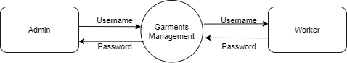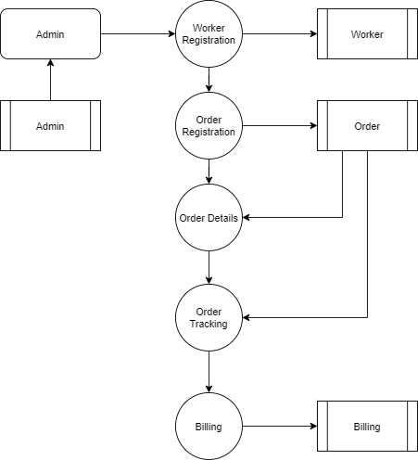.

TABLE NAME: ADMIN

FIELD | DATA TYPE | SIZE | CONSTRAINT
Admin id | Int | 10 | Primary key
Username | Varchar | 30 | Not null
password | Varchar | 30 | Not null

TABLE NAME: WORKER

FIELD | DATA TYPE | SIZE | CONSTRAINT
Worker id | Int | 10 | Primary key
Name | Varchar | 30 | Not null
Mobile | Int | 10 | Not null
Company name | Varchar | 20 | Not null
Address | Varchar | 25 | Not null
Gender | Varchar | 10 | Not null
Age | Int | 5 | Not null

TABLE NAME: ORDER

FIELD | DATA TYPE | SIZE | CONSTRAINT
Order id | Int | 10 | Primary key
Worker id | Int | 10 | Foreign key
Order status | Varchar | 15 | Not null
Order quantity | Int | 10 | Not null
Order details | Varchar | 20 | Not null
Expected delivery | Date | 10 | Not null

TABLE NAME: BILLING

FIELD | DATA TYPE | SIZE | CONSTRAINT
Billing id | Int | 10 | Primary key
Order id | Int | 10 | Foreign key
Worker id | Int | 10 | Foreign key
Amount | Int | 10 | Not null

